7-Step U.S. Patent Search Strategy Guide



**U.S. Patent Search Assistance at a PTRC**

Patent and Trademark Resource Center (PTRC) library staff are available to provide training on U.S. patent search processes and research tools including **PubWEST, PubEAST** and the **USPTO website’s PatFT and AppFT patent publication databases**. For the PTRC nearest you, check [www.uspto.gov/ptrc](http://www.uspto.gov/ptrc). For legal questions, contact an attorney or agent registered to practice before the USPTO. A listing is available at <https://oedci.uspto.gov>.

**U.S. Patent Prior Art Search vs. Comprehensive Prior Art Search**

This guide provides a 7-step strategy for searching U.S. patents and published patent applications to locate and evaluate relevant prior art, any previous publication that discloses an invention and would preclude issuance. A comprehensive prior art search would also include foreign patent publications and non-patent literature (newspapers, magazines, dissertations, conference proceedings, and websites). PTRC staff can also provide training on how to locate these additional resources.

**Search Preparation and Documentation**

Plan on spending a few hours learning the search process and additional hours for searching and evaluating results. The length of search time depends on the complexity of the invention. Careful recording of the search process (databases used, date and time of search, classes searched, and patents/published patent applications retrieved) is important.

**1**

**STEP 1:**

**Brainstorm Terms Describing Your Invention**

Begin by writing down a brief, accurate description of the invention. Avoid overly broad and generic terms such as “device,” “process” and “system.” Consider synonyms for the terms you initially select. Note important keywords and technical terms. Use the following questions to help identify keywords and concepts.

* What is the purpose of the invention? Is it a utilitarian device or an ornamental design?
* Is the invention a process – a way of making something or performing a function – or is it a product?
* What is the invention made of? What is the physical composition of the invention?
* How is the invention used?
* What are keywords and technical terms that describe the nature of the invention? Consult a technical dictionary or thesaurus to help find the appropriate terms.

For our search example, we have invented an umbrella with a new rib design to eliminate the umbrella collapsing or inverting due to winds.



*Purpose: Umbrella has a new rib design to eliminate an umbrella collapsing or inverting due to high winds.*

*Invention: An improvement in umbrellas to eliminate need for frequent replacement of umbrellas.*

*Invention Components: Framework with ribs, stretchers and a main frame, securing rings, mounting brackets, joint connectors, fabric connectors, fabric, linkage bar.*

*How used: As needed in protection from the elements.*

*Other terms (in addition to above): Parasol, sunshade, support assembly or apparatus, windproof, wind-resistant.*

**STEP 2:**

**2**

**Access and Review Cooperative Patent Classification Schema Using USPTO’s Website Site Search Feature**



The USPTO home page ([www.uspto.gov](http://www.uspto.gov)) has a USPTO.gov Site Search text box in the top right corner. CPC classification schema (class schedules) can be searched using this text box. Use specific language for your search terms, such as *CPC scheme umbrella*. Typing in simply *umbrella* would be too broad and provide many unrelated results.

From the Search Results page, click on an entry for a Class-Subclass Scheme page.

If you are not satisfied with the search results, rerun your search using synonyms you identified in Step 1 for your invention.

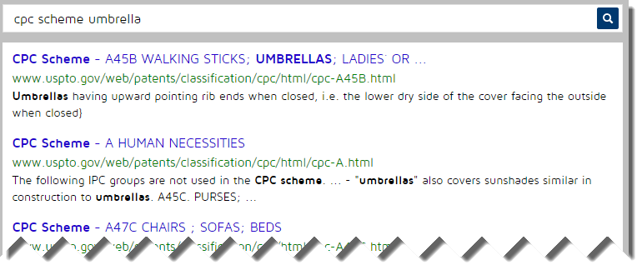

Scan the classification titles in the class scheme for A45B looking for the most relevant classification. Dot indents are used to show hierarchical relationships in the scheme. The more dots the more specific the concept is. Some titles may have references in parenthesis following the title that aid in the classification selection. We find **A45B 25/22** as a possible good match based on the title **“Devices for increasing the resistance of umbrellas to wind.”** There is nothing under A45B 25/22 with two dots that is more specific, so this may be a good choice.

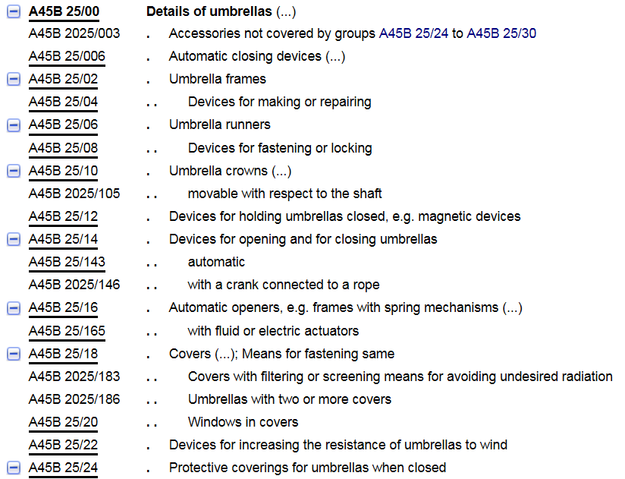

**A45B 25/22—best match**

**3**

**STEP 3: Review Classification Definition Linked to the CPC Classification You Selected**

If the selected classification title is underlined, it is hyperlinked to a CPC Classification Definition. CPC Classification Definitions are helpful in establishing the scope of the relevant classification and thus ensuring you have selected the most relevant classification. The definitions may include important search notes and suggestions for further searching.

In this example, we click on A45B 25/22 and get the following definition which is unusual in that it relies solely on images (most CPC definitions use text).

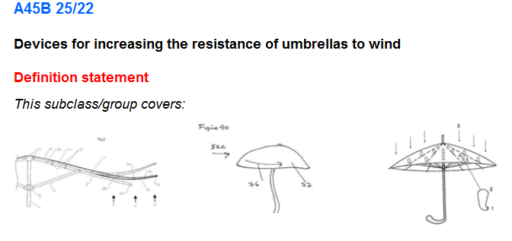

**STEP 4: Retrieve and Review Issued Patents Using the CPC Classification You Selected**

**4**

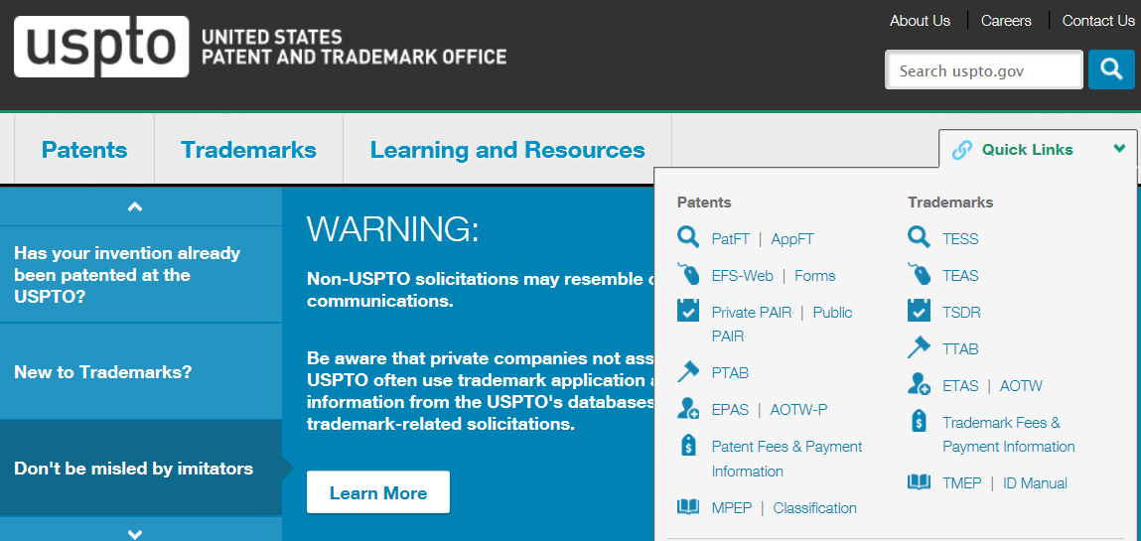

**Click on PatFT under “Quick Links”**

Having identified a relevant CPC classification, use the CPC classification to retrieve and review all the U.S. patents currently assigned to that CPC classification in the PatFT (Patents Full-Text and Image) database on the USPTO website. On the USPTO home page ([www.uspto.gov](http://www.uspto.gov)), select “PatFT” under the drop-down “Quick Links” menu.

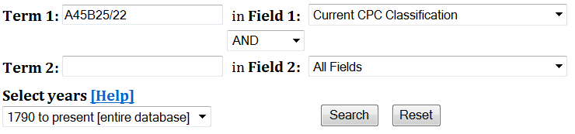

Enter the CPC classification in Term 1 Box (important: delete the space in the middle of any CPC classification when doing a PatFT search, so enter “A45B25/22”.). In the Field 1 drop down box select “Current CPC Classification.” Leave the Term 2 Box blank. For Select Years, use the drop down box to select “1790 to present [entire database]”. Click on the Search button to get results.

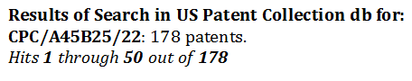

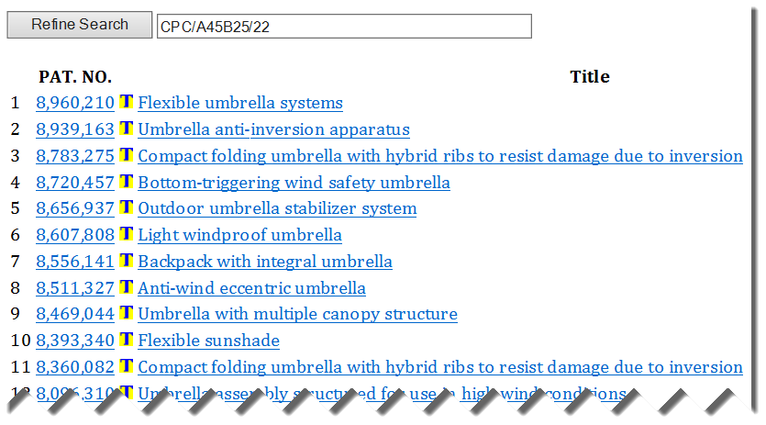

Click on either the patent number or the patent title to see the full-text of the patent (patents issued prior to 1970 will not have a full-text version, only a limited text entry). Click on the red **“Images” button** at the top of the page to view a pdf image of the patent. Review the front page of each patent in the Results List, paying special attention to the abstract and representative drawing. Jot down the number of those patents you feel are similar to your invention that will merit later closer review.

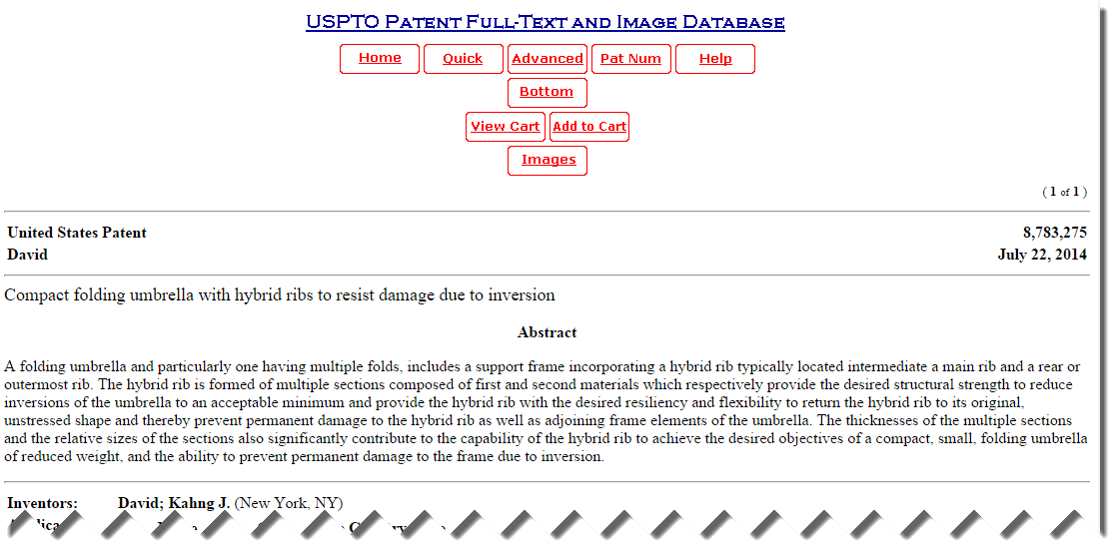

This is the html full-text of the patent. Click “Images” button to view .pdf image of the patent on display.

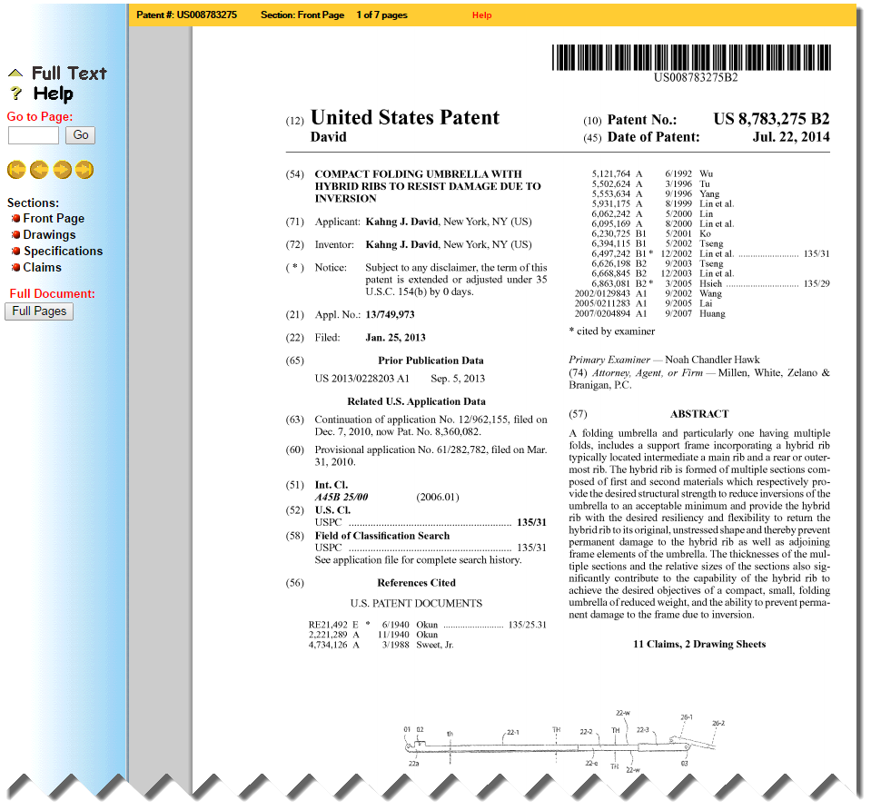

Click “Full Pages” button to view, print or download ALL of the pages of the patent.

**STEP 5: Conduct In-Depth Review of Patents You Selected Based on Their Front-Page Information**

**5**

Using this selected set of most relevant U.S. patents, now review each one in-depth for similarity to your own invention, **paying close attention to the other sections of the patent--additional drawings pages, the specification and especially the claims**. References cited by the applicant and/or patent examiner may lead you to additional relevant patents. Remember the claims constitute the boundaries of legal property rights given to the patent holder. Print or download copies of the most relevant U.S. patents you find.

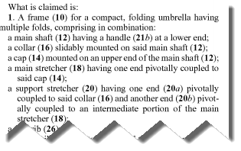

**6**

**STEP 6: Retrieve and Review Published Patent Applications Using the CPC Classifications You Identified**



**Click on AppFT under “Quick Links”**

Use the CPC classification you selected in Step 3 to retrieve and review all the U.S. published patent applications currently assigned to that CPC classification in the AppFT (Patents Full-Text and Image) database on the USPTO website. On the USPTO home page (www.uspto.gov), select “AppFT” under the drop-down “Quick Links” menu.

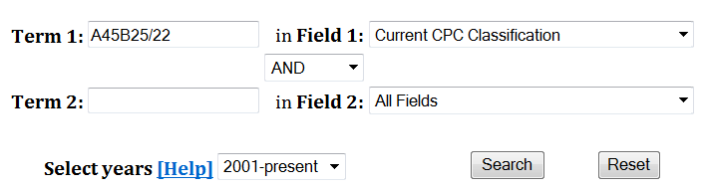

Enter the CPC classification in Term 1 Box (important: delete the space in the middle of any CPC classification when doing an AppFT search, so enter “A45B25/22”.). In the Field 1 drop down box select “Current CPC Classification.” Leave the Term 2 Box blank. For Select Years, you can only select “2001-present” since the U.S. has only been publishing patent applications since 2001. Click on the Search button to get results.

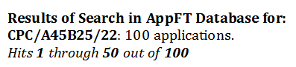

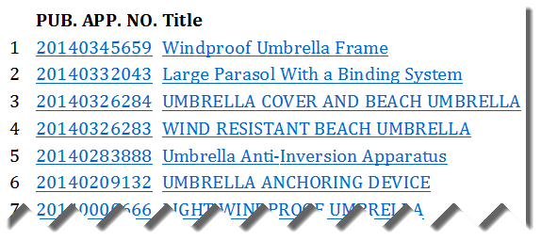

As you did in Step 4 with your Patent Results List, click on either the published patent application number or its title to see the full-text version. Click on the red “Images” button at the top of the page to view a pdf image of the published application. Review the front page of each published patent application, paying special attention to the abstract and representative drawing. Jot down the number of those published patent applications you feel are similar to your invention.

Using this selected set of most relevant U.S. published patent applications, now review each one in-depth for similarity to your own invention, paying close attention to the other sections of the published application--additional drawings pages, the specification and especially the claims. Print or download copies of the most relevant U.S. published patent applictions to your invention.

**7**

**STEP 7: Options for Broadening Your Search**

Having completed a preliminary U.S. Patent and Published Patent Applications search in which you did not find publications that disclosed what you hope to protect in your own patent application, you have several options to Broaden your Search--based on available time and resources.

1. You can supplement your CPC classification search in the PatFT and AppFT databases by using **Keywords** to search. A Keyword search may simply turn up documents that were not well classified or perhaps had classifications you missed in your review of CPC schema in Step 2. U.S. patent examiners regularly supplement their classification searches with keyword searches. Group (using “OR”) together synonyms and especially consider the use of technical engineering language rather than common everyday words, e.g., (car or automobile or auto or “land motor vehicle”). Use truncation symbols to get singular and plural versions of a word (airbag$). Use quotes to group search phrases where words are adjacent (“image viewer”).
2. Broaden your search with **U.S. Patent Classification (USPC)**. While U.S. Patent Classification ended being used on U.S. utility patents on 1/1/15, the classification system remains searchable for all pre-2015 U.S. utility patents. If you found relevant U.S. patents or published patent applications using CPC, note their current U.S. Patent Classifications in their html version. You can then run a USPC search in PatFT (and separately in AppFT) while NOT’ing out (eliminating) the publications you previously saw using CPC so you don’t have to review any of the same publications again. Your PTRC librarian can show you how to use USPC.
3. Extend your seach to foreign patents and published patent applications using the CPC classification you identified in Step 3. Re-run your search using **Espacenet** (<http://worldwide.espacenet.com> ), the European Patent Office’s worldwide patent publication database of over 90 million patent publications. Your PTRC librarian can also show you how to search Espacenet.
4. Since inventions can be publicly disclosed in a variety of **non-patent print and electronic publications**, you can choose to search books, journals, websites, technical catalogs and conference proceedings as well. Depending on the print and electronic databases, your nearest PTRC provide public access to a PTRC library staff member can show you how to search these also.
5. Having conducted a preliminary patent search, you may choose to hire a **registered patent attorney or patent agent** to review your search and conduct a follow-up search of his/her own. Because you have already done preliminary reasearch, you are better prepared to discuss your invention and related inventions you found with a patent professional. Plus, the attorney won’t have to spend time (and money) covering patenting basics, if you’ve used your research time wisely. To search for a Registered Patent Attorney or Patent Agent, consult the USPTO’s online roster at <https://oedci.uspto.gov>.

**Business Planning & Marketing**

PTRC libraries can provide additional resources detailing the business planning process, licensing, and marketing of inventions. Also *beware* of fraudulent invention promotion firms – see [www.uspto.gov/inventors/scam_prevention/index.jsp](http://www.uspto.gov/inventors/scam_prevention/index.jsp)



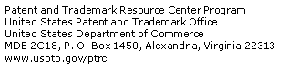

***Disclaimer:*** *The information contained in this guide is not intended as a substitute for professional legal advice. Use it as a general guide for conducting a U.S. patent publication prior art search. The USPTO recommends that inventors consult a registered patent agent or attorney prior to filing a patent application.*

TT 4/2015