Most dates and values for the calculator can be located at http://portal.uspto.gov/external/portal/pair. This is the Public PAIR portal which does not require a password to use.
You will first encounter a “Captcha” screen which is used to prevent abuse of the system by data harvesting programs.
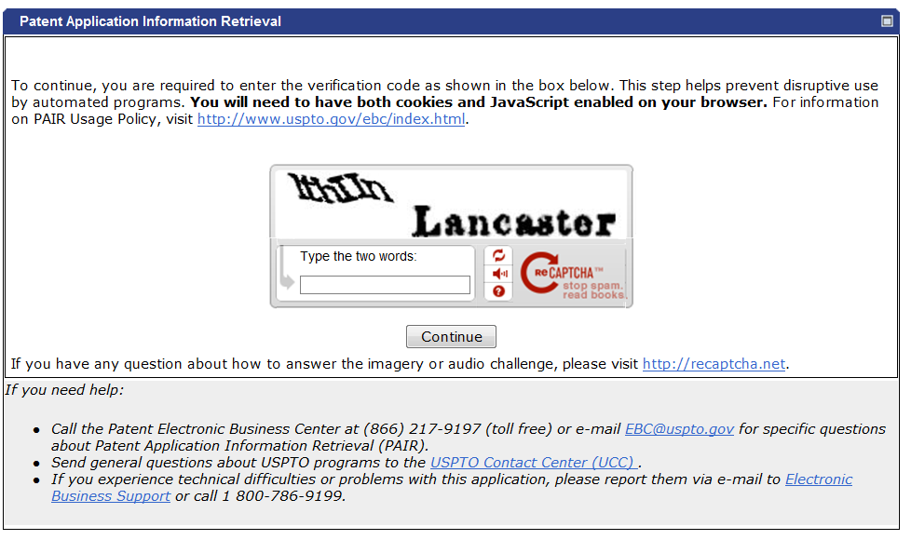
Next you will select “Patent Number” and enter a valid U.S. Patent number to start your search.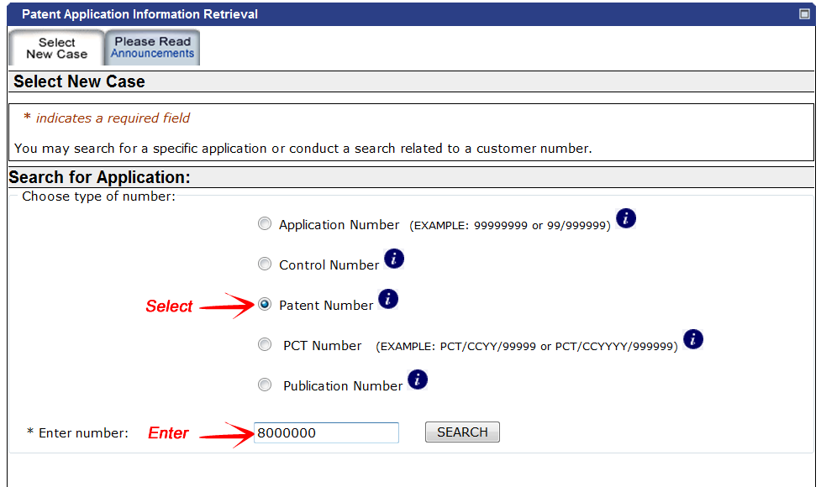

The initial PAIR screen (Application Data) contains several required pieces of information to determine your patent term. It also has tabs to other data that is required.
On this screen you can obtain the Application Number (used for Fee search), Filing Date, Application Type and Issue Date (Grant Date).
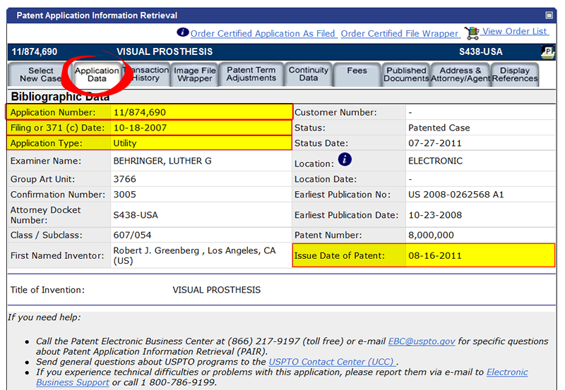

If any Patent Term Adjustments or Patent Term Extensions under 35 U.S.C. § 154 exist, the amounts will be listed under their own tabs on Public PAIR.
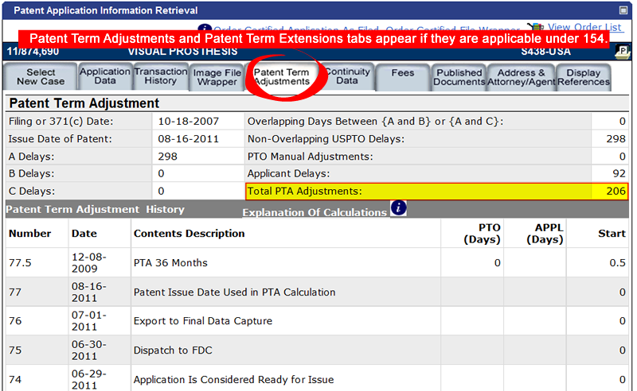

Continuity Data is used to determine domestic filing date benefits derived from being a continuation, continuation-in-part or divisional application.
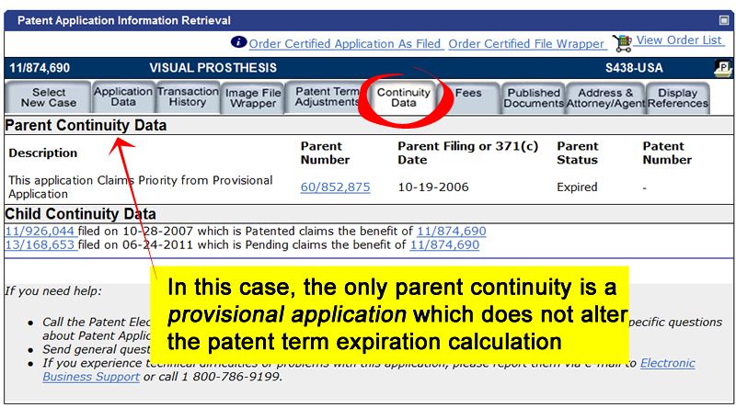

You can check if payments on maintenance fees are up to date by selecting the Fees tab in PAIR. A Patent Maintenance Fees window will pop up. The patent number will be pre-populated but you will have to enter the application number (from the Application Data page of PAIR). There are three payment “windows” – 4, 8 and 12 years to check using the dropdown box.
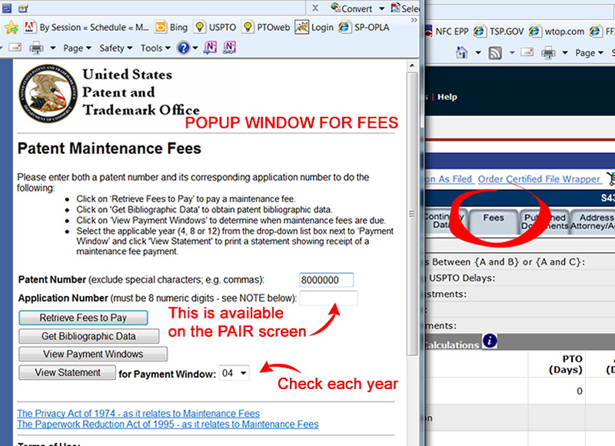

One way to determine if a terminal disclaimer exists is to check the front page of the patent image. You can do so by searching the AppFT database. The link is located at http://patft.uspto.gov/
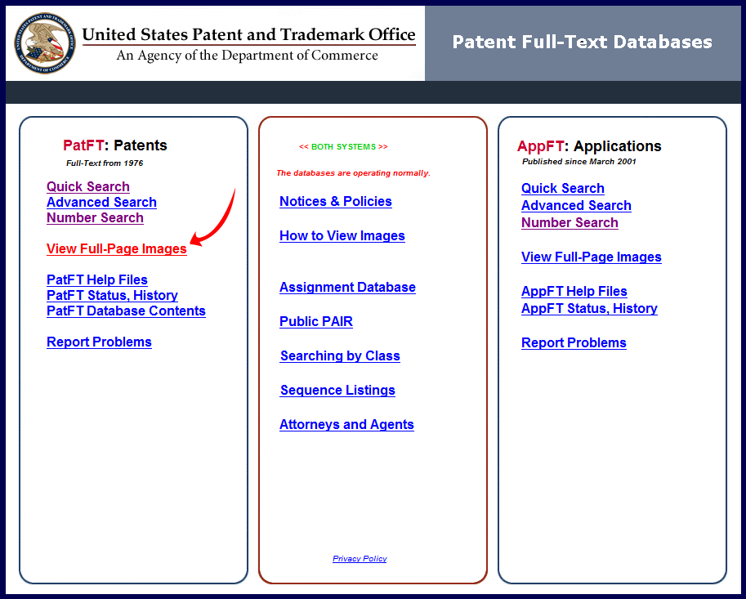

On the first page of the patent, there is a Notice section on the top left which indicates the presence of PTA, PTE and terminal disclaimers (TD). Because PTA can be modified by petitions following issuance, please refer to PAIR for accurate PTA and PTA values. The presence of a terminal disclaimer alerts you to inspect the Image File Wrapper in PAIR for terminal disclaimer documents for detailed information. If a TD exists, you will have to perform expiration calculations for the referenced patent before you can finish the current patent’s calculation.
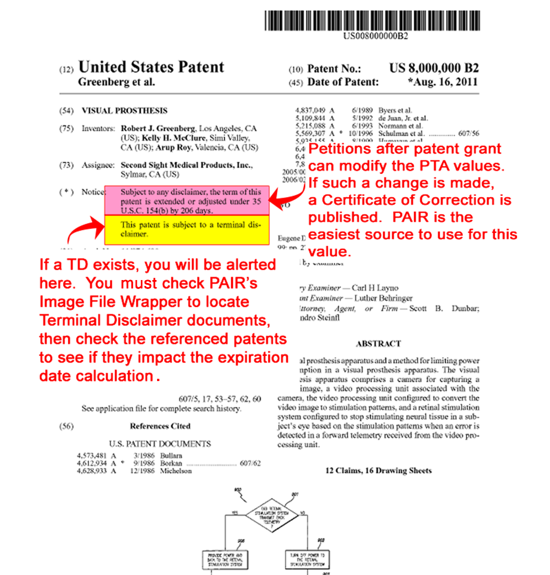

This illustrates how to look up a terminal disclaimer document using PAIR’s Image File Wrapper tab.
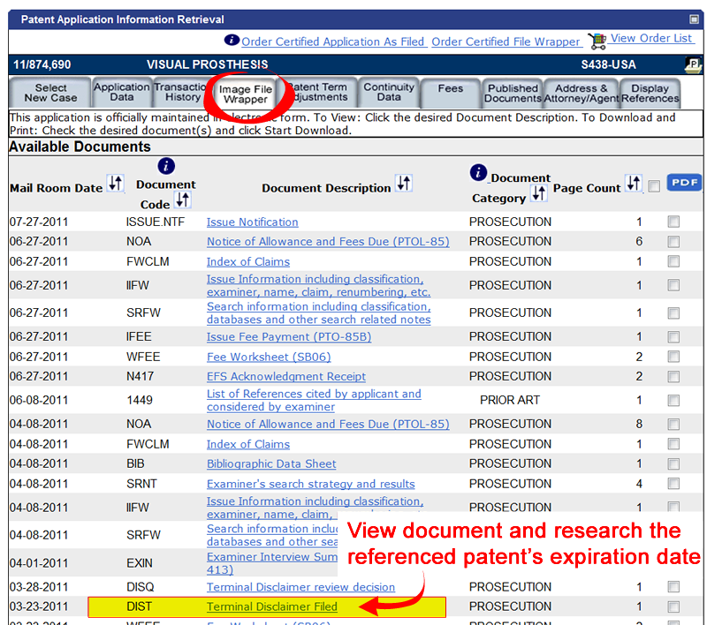

There is a special page for Patent Term Extensions under 35 U.S.C. § 156:
http://www.uspto.gov/patents/resources/terms/156.jsp
